|  |
| --- |
| **MATHEMATICS DEPARTMENT 2015**  **Year 11 Specialist - Test Number 5**  Trigonometric Identities and Complex Numbers |



**Name: _______________________________ Teacher: DDA**

**Marks: 50**

**Time Allowed: 45 minutes**

**Instructions:** You arepermitted 1 page notes but no calculator.

_________________________________________________________________________

**Part A**

8 multiple-choice questions

1 mark each: 8 marks

Circle the correct answer.

1 sec (60°) =

A 2

B 

C 

D 

E 

[1 mark]

2 sin  =

A −2

B 

C 

D 

E 

[1 mark]

3 sin (90° + α) =

A sin (α)

B −sin (α)

C cos (α)

D −cos (α)

E sin (90°)

[1 mark]

4 The graph shown below could have the equation:

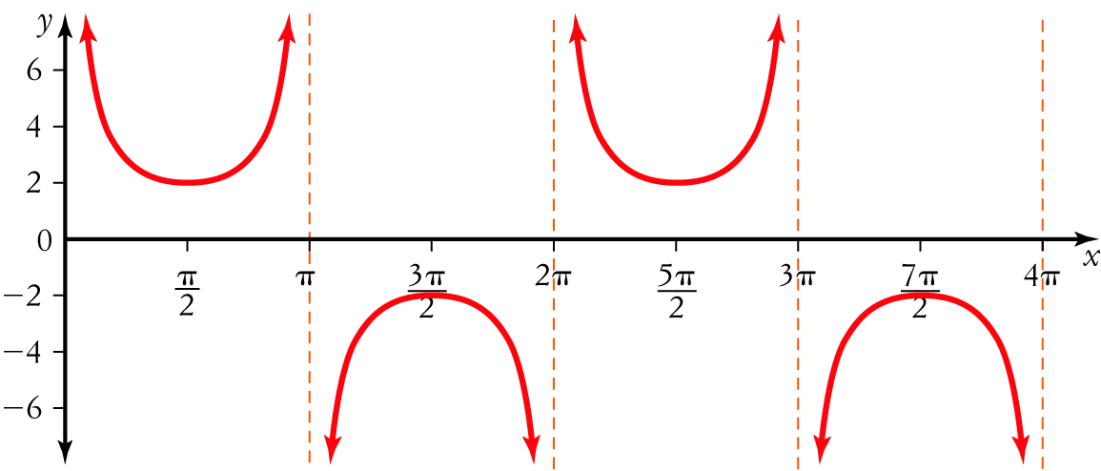

A y = 2 cosec (x)

B y = 2 sec (x − 1)

C y =  cosec (x)

D y =  sin (x)

E y = cosec 

[1 mark]

5 mod =

A 4

B –2

C 

D 2

E 2i

[1 mark]

6 The value of  is:

A i

B 1

C –1

D –i

E 

[1 mark]

7 

A 3 – i

B –3 – i

C –3 + i

D 3 + i

E 3 + 3i

[1 mark]

8 The solutions to the quadratic equation x2 + 16 = 0 are:

A 

B ±4

C ±4i

D 

E ±2i

[1 mark]

**Part B**

10 short answer questions

29 marks

Show your working where appropriate.

9 Express the following in the form a+bi: 

[2 mark]

|  |
| --- |
|  |
|  |
|  |
|  |
|  |
|  |
|  |
|  |
|  |
|  |
|  |

10 A quadratic equation has roots  . Express it in the form

[2 mark]

|  |
| --- |
|  |
|  |
|  |
|  |
|  |
|  |
|  |
|  |
|  |
|  |
|  |

11 Sketch the graph of y = −sec (x) + 1 for 0 ≤ x ≤ 4π.

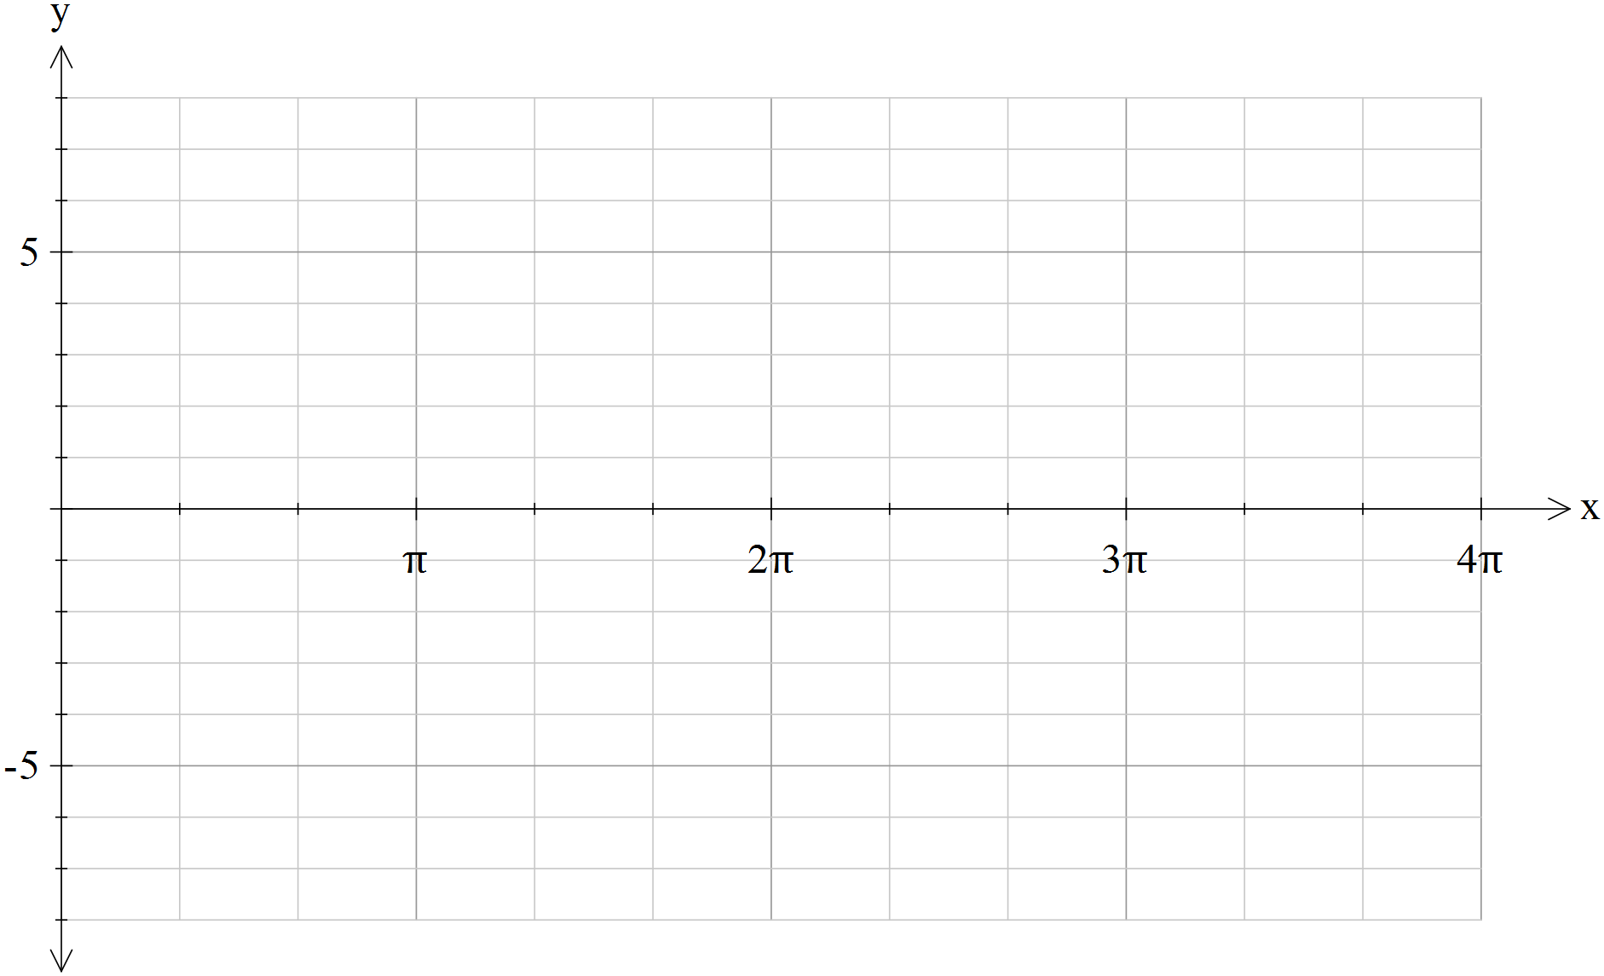 [4 marks]

The grids below this point are for you to use to assist in your thinking on paper. Nothing below this sentence on this page will be marked and there use is optional.

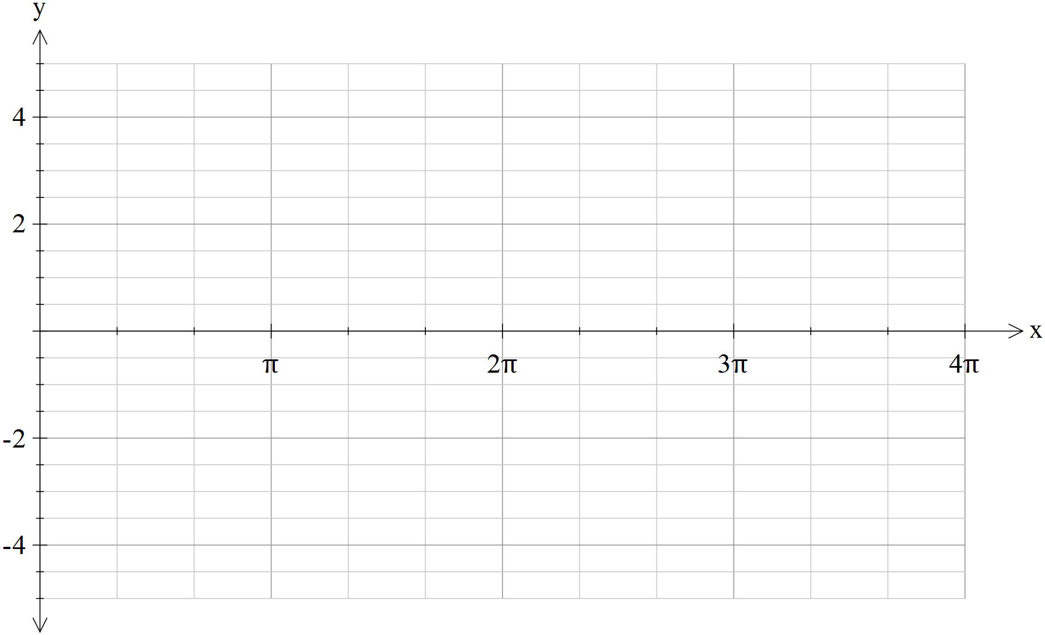

12 Using the Pythagorean identity sin2 (θ) + cos2 (θ) = 1 evaluate cos2  given that sin.

|  |
| --- |
|  |
|  |
|  |
|  |
|  |
|  |
|  |
|  |
|  |
|  |
|  |
|  |

[3 marks]

13 Using a suitable compound angle formula evaluate tan .

|  |
| --- |
|  |
|  |
|  |
|  |
|  |
|  |
|  |
|  |
|  |
|  |
|  |
|  |
|  |
|  |

[4 marks]

14 Express cos (60°)  cos (15°) as a sum. DO NOT evaluate.

|  |
| --- |
|  |
|  |
|  |

[1 mark]

15 If w = 2 – 3i, the points A, B, C and D correspond to the vectors  and iw. [5 marks]

a State the coordinates of the points A, B, C and D.

|  |
| --- |
|  |
|  |
|  |

b Plot the points A, B, C and D on an Argand diagram.

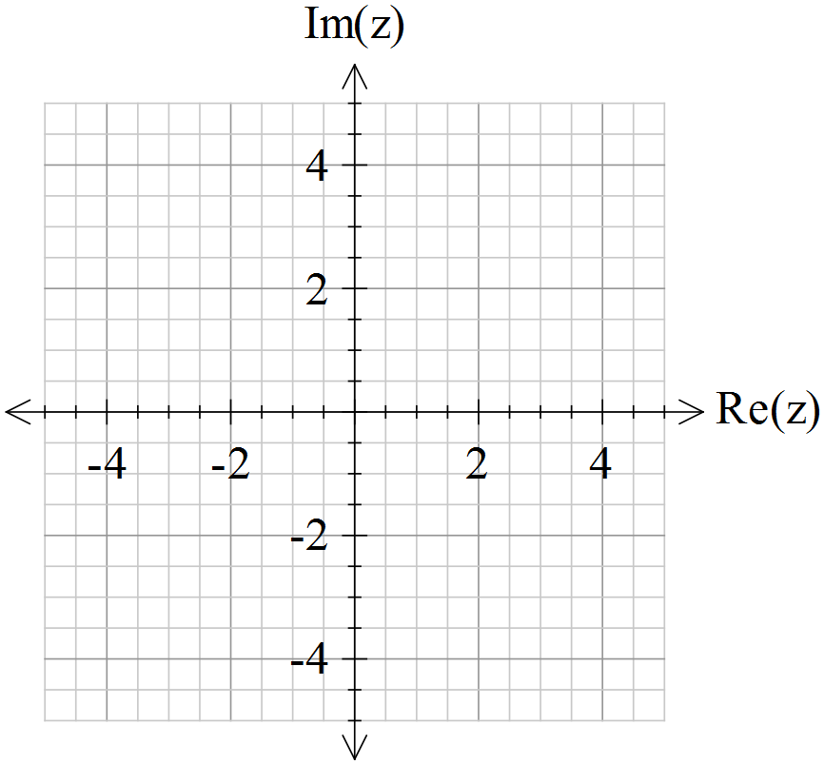

[5 marks]

16 Consider the complex numbers z = –1 +  and w = .

a Find Im(z + w).

|  |
| --- |
|  |
|  |

b Find Re(zw).

|  |
| --- |
|  |
|  |

[4 marks]

17 Solve the equation x2 – 8x + 17 = 0 in the complex plane.

|  |
| --- |
|  |
|  |
|  |
|  |
|  |
|  |
|  |
|  |
|  |

[2 marks]

18 Realise the denominator on , expressing your answer in the form a + bi, where a, b  R.

|  |
| --- |
|  |
|  |
|  |
|  |
|  |
|  |
|  |

[2 marks]

**Part C**

3 analysis questions

13 marks

Show your working where appropriate.

19 Rewrite the expression sec (x) sin (2x) − sin (x) cos (2x) in terms of sin (x) only.

[3 marks]

|  |
| --- |
|  |
|  |
|  |
|  |
|  |
|  |
|  |
|  |
|  |
|  |
|  |
|  |
|  |
|  |
|  |
|  |
|  |
|  |
|  |
|  |

20 Prove that 1 + tan2 (x) = sec (x) cosec (x) tan (x).

[3 marks]

|  |
| --- |
|  |
|  |
|  |
|  |
|  |
|  |
|  |
|  |
|  |
|  |
|  |
|  |
|  |
|  |
|  |
|  |
|  |
|  |
|  |
|  |

21 Prove each of the following for z = x + yi, where x, y R:

a 

|  |
| --- |
|  |
|  |
|  |
|  |
|  |
|  |
|  |
|  |
|  |
|  |
|  |
|  |
|  |
|  |
|  |
|  |

b 

|  |
| --- |
|  |
|  |
|  |
|  |
|  |
|  |
|  |
|  |
|  |
|  |

[4,3: 7 marks]

Total marks: 50